BDA Lab Outputs

Name: Karkala Gaurav Prabhu

USN: 1BM17CS136

1. Create a keyspace by name Student.

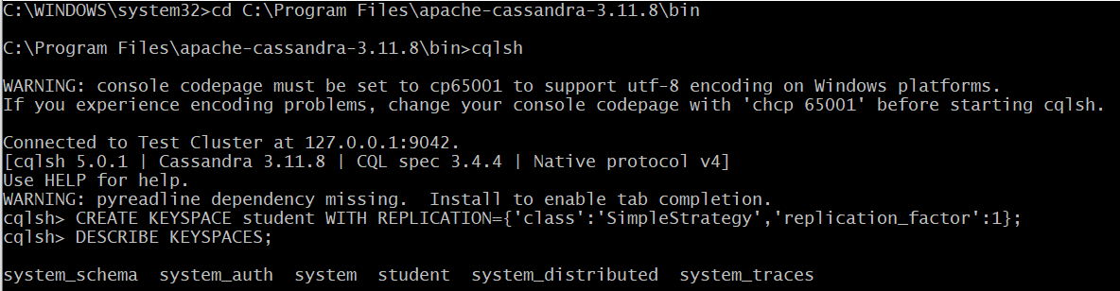

1. Create a column family by name Student-Info with attributes Student_Id Primary Key, Stude_Name, Date_of_Joining, Semester, Dept_Name.



1. Insert the values into the table in batch.

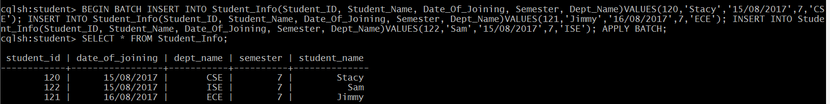

1. Update Student name of Student_Id 121.